**How to resolve smartphone screen locked problem**

I switched the sims card in my phone to fix my Samsung s6 edge phone. The problem that the Samsung had was that it was locked, and I could not make any call. I called T-Mobile and asked why the phone was locked. T Mobile customers told me it was reported stolen.

when I put the sims card back into my Lenovo phab 2 back into it, the phone could not recognize the screen password. I tried all I could do to unlocked it, but I couldn’t resolve the problem.

I search google for possible information on how I can solve the problem.

I found a link on google to make google locate my phone. I clicked on the link, I was prompted to enter my phone number and my google account information. I did and click on the option that say next and google was able to locate my phones.

Now I had the following options:

1. Locked the phone
2. Erase the data and contact on the phone
3. Played the phone.

I chose option 2, to erase the data and contact on the phone. Google started erasing everything on the phone. After it was complete, I have option to enter a new password before restarting the phone. I entered the new password and restart the phone. After the phone finished rebooting up, I entered the new password; and the phone came up with new option to reset the phone to factory set. I checked the option and click next. Google started to reinstall the operation system, and updated it. It took about 30 minutes before the installation was complete.

At the end of the installation process, the phone restarted automatically by itself. I was asked to enter my password which took me to home screen. The problem was totally resolved.

**How to resolve smartphone on the screen keyboard problem.**

I had another phone with on the screen keyboard problem.

This phone because it was not registered with google account. I couldn’t use good to fix the problem.

I bought a program to fix the problem. The name of the program is “Wondershares Mobilego”.

I bought this program on the internet and installed it on my laptop.

When I open the application, I have the following option on how I can transfer data from my laptop to my phone.

The next thing I did was to my phone manufacturer website and download the operating system onto my laptop top, which I save on the desktop. Below is the option I have when I opened wondershare mobilego program.

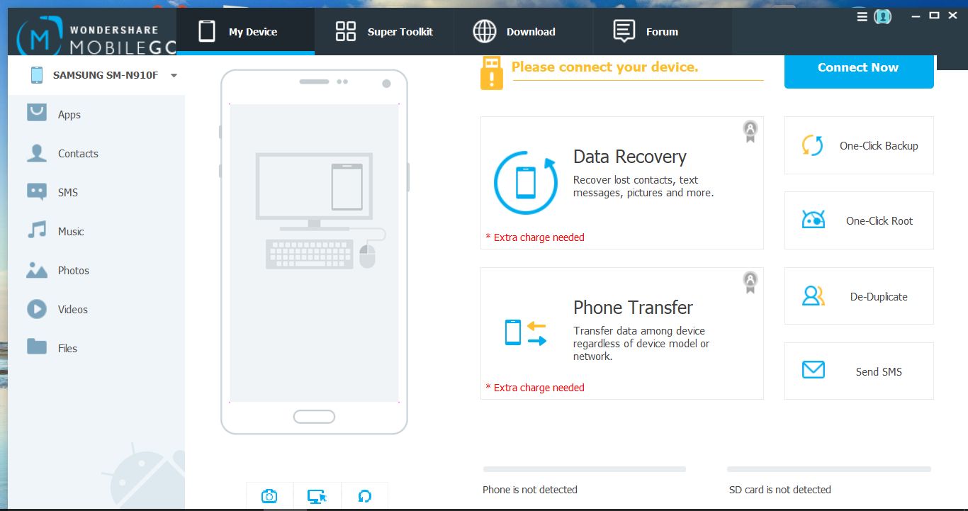

I now used the phone micro USB cable to connect it to the laptop. After that I opened the wondershares mobile application and click phone transfer option. The program recognized my phone as a drive on the pc. I looked for the operation system I download from the manufacturer website and started installing it onto smartphone. The application makes it possible to install from a laptop on to a smartphone. Installation of the operating system and the update took about 15 minutes.

When the installation was complete the phone rebooted automatically, it set the phone to factory set. To recover my data, I now click on data recover option. I was able to recover my lost contacts, text messages, pictures and more. Before can recover the lost data, one must have setup google account.